West Australians receive compensation after being duped in rent-to-buy property scheme
By Rhiannon Shine
Posted Thu 5 Nov 2015 at 8:19pmThursday 5 Nov 2015 at 8:19pm, updated Tue 17 Nov 2015 at 2:56pm

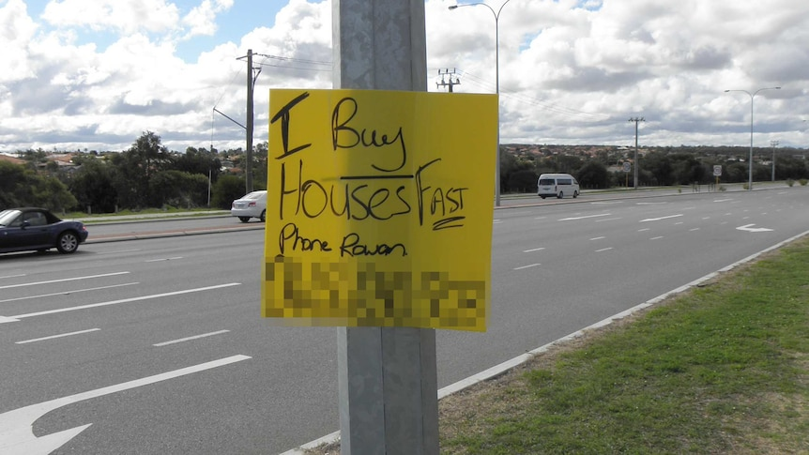

Three West Australians have received a total of $70,000 in compensation after they were duped by a rent-to-buy property scheme.
The compensation followed settlement of Supreme Court action by Consumer Protection against Presto Property Solutions and its director Rowan Amanda Lines.
Ms Lines admitted she made false and misleading representations to prospective buyers and tenants in 2010.
Among the victims were a Quinns Rock couple, who contacted Presto Property Solutions after they saw a sign that said "we sell houses fast" posted on a light pole.
The Quinns Rock couple signed up for a rent-to-buy scheme to sell their property.
Consumer Protection claimed Ms Lines later purported to be the owner of the couple's Quinns Rock property when dealing with the tenant/prospective buyer.
Acting Consumer Protection commissioner Gary Newcombe urged consumers to exercise caution when considering a rent-to-buy agreement.
"In this case the Quinns Rock couple returned from overseas almost a year later to discover the tenant [and prospective buyer] had sold their above ground swimming pool which had a replacement value of $16,000," he said.
"This highlights the confusing nature of these agreements where the line between tenant and owner is blurred and the legal rights of all parties are unclear."

Rent-to-buy schemes 'extremely convoluted'
Consumer Protection Director of Property Industries Steve Maegher said rent-to-buy schemes were extremely convoluted.
"The best way to describe rent-to-buy schemes is like a lay-by arrangement but to buy a house and with many risks attached," he said.
"These are schemes where people arrange to buy a house but it's a convoluted process whereby they pay [various] fees and there is just no guarantee at the end of the day that a person will get a bank loan to buy the property.
"There are risks for both the person buying the property and the seller.
"The risk for the person buying the property is that if they don't go ahead with the sale at the end they lose all of the money they paid.
"But the risk for the seller is that they are locked into a deal for between three and five years."
Mr Maegher said vulnerable people were being targeted.
"They are people who can't get loans through traditional methods and they are desperate to get into the housing market," he said.
"So they are risking a lot of money, they pay a lot of money up front, and if there is any breach or if they are late with payments, they can lose all the money they put in."
Editor's Note: This article has been amended in response to concerns raised by Presto Property Solutions and Rowan Amanda Lines to clarify that the Supreme Court action in question was resolved through entry into a settlement agreement and Enforceable Undertakings, and not through Court findings following a trial.
Posted 5 Nov 2015, updated 17 Nov 2015

